2024 8834 JC2 H1 Geography Preliminary Examination
(Suggested Responses)

Cluster 2 Fieldwork
1(a) | Explain why the hypothesis is appropriate for the investigation.  Indicative content  To determine appropriateness of the hypothesis, students are to consider if the hypothesis is:  - clearly defined - it includes both an independent variable (drivers in Tampines estate) and a dependent variable (willingness to buy electric car) at a well-defined area of investigation i.e. at the Tampines estate.  - researchable – surveys and interviews can be conducted with the drivers living in Tampines estate to determine their willingness to buy electric cars.  - Students have easy access to the equipment (just questionnaire surveys)  - at a suitable scale – the sampling sites are located near each other and is easily accessible by transport as shown in Resource 1 such as the MRT station. Thus the close proximity of these sites would be manageable for the students to collect data within one afternoon. There are also sufficient manpower (12 students) to carry out the surveys, can split into groups of 4 and each group can collect ___ surveys | [4]
(b) | With reference to Resource 1, explain the factors that the students could consider when choosing the site to carry out the survey.  Indicative content  - Could consider whether the site is frequented by drivers to ensure that a reliable number of drivers can be surveyed about their willingness to buy electric cars  - Ensure that the sites are easily accessible by the students and should not pose any form of endangerment to their safety while conducting the surveys.  - The sites chosen should also have some form of safe shelter in the event of rainy weather for them to seek refuge from. | [3]
(c) | Referring to Resource 2, explain ethical issues that may arise due to the students’ data collection at the shopping mall’s entrance.  Indicative content  - The students did not obtain permission from the management/staff of the shopping mall to survey the shoppers at its premises [1 mark]. As such, the shopping mall’s management may misunderstand the students’ intentions of collecting such data, and may not appreciate the students’ actions [1 additional mark].  - The students may inadvertently affect the shopping mall’s business because their actions could have prevented potential customers from patronizing the shops there. [1 mark] As it is not possible to identify the shoppers as drivers, the students may have to ask every shopper and given that the survey questions require some time to complete, that could possibly deter some shoppers from entering the mall. [1 additional mark]. | [4]
(d) | With reference to Resource 2, explain how the students’ survey form may affect the reliability of data collected.  Indicative content:  - The phrases “strong influence” and “some influence” in the questionnaire for question 3 tend to be ambiguous and subjective [1 mark]. Such phrases may be interpreted differently by different participants, which may affect the reliability of the students’ data [1 additional mark].  - The request for respondents’ names on the forms may affect the reliability of the responses, since respondents may become more conscious about how their responses may be interpreted [1 mark]. For instance, since respondents know that their responses can be ‘traced’ back to them, they may refrain from indicating that they are not willing to buy electric cars as it badly reflects their lack of environmental responsibility/awareness. [1 additional mark]. | [4]
(e) | Sketch a diagram to represent the data collected shown in Resource 3.  Indicative content  - Title, Appropriate Axes, Correct Labelling and %  - Compound bar chart showing clearly the relative proportions of each specific item.  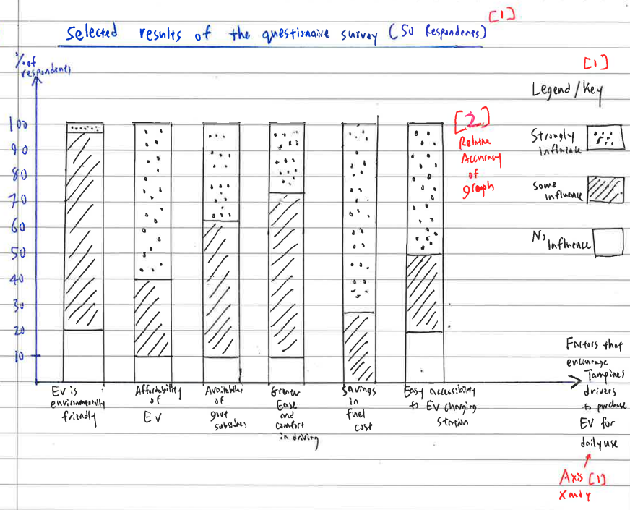 | [5]
(f) | Evaluate the students’ investigation and explain how it can be improved.  Indicative content  Students are to EVALUATE their methods of data collection and the data collected – MUST show BOTH strength(s) and limitations.  Possible Strength:  - The questionnaire survey is short and easy to complete – this incentivizes the respondents to participate in the survey, increasing the sample size and thus making the responses more representative of the population and hence yielding a more reliable result.  Limitations and how it can be improved:  - Reliability of 50 respondents may not be very representative - Convenience sampling method is bias, because they are only getting people who are willing to answer their survey and they did not manage to distinguish between different type of users and whether they are car owners, or if they already own electric cars  - Use stratified sampling instead to profile different strata/groups of respondents so it is more representative – e.g. young adults, older adults, working population, young families to understand what factors would influence different type of population to want to drive electric cars  - Fieldwork was conducted only around the central area of the Tampines estate, neglecting the other parts of the estate. would be more reliable to carry out the investigation at other streets further away from the central area for a more representative data.  - Fieldwork was only conducted on one Monday afternoon – data collected may not be reliable as some drivers may have weekend cars and they may have been left out of the survey or drivers surveyed in the afternoon are leisure drivers or grab drivers only and may not be wholly representative of those who drive to work in the mornings and returning from work in the evenings it could been extended to be conducted on other days of the week (e.g. weekday vs weekend) or other timing of the day e.g. one time in the morning, and another time in the evening to collect a more representative data, and more reliable analysis.  - 50 Respondents over three locations also do not represent an equal number of respondents across the three sites. Students can aim for 30 or more respondents at each site to be statistically significant and combining the total respondents  - Only close-ended questions are included in the survey questionnaire that may be too narrow a representation of data collected as close-ended questions do not offer any meaningful qualitative responses or elaborations of answers given it would be better to include some open-ended questions to elicit more details with regard to the responses given so that data given can be more reliable with a mix of both quantitative and qualitative data. | [10]
2(a) | Describe the global urban population growth from 1950 to 2030 as shown in Resource 1  Indicative content  - Resource 1 shows that globally, all continents in the world will experience an increase in their urban populations from 1950 to 2030.  - The less developed regions like South America, Africa and Asia will see a higher projected increase of at least about 40 percent in their urban populations compared to the more developed regions like Europe, North America and Australasia that are expected to only increase by a lower percentage of between 14 to 29 percent.  - The region/continent with the highest projected increase of 43 percent in urban population is South America.  - The lowest projected increase of just 14 percent in urban population is observed to be from Australasia. | [4]
(b) | With evidence from Resource 5, state and explain the relationship between urbanisation level and GDP per capita.  Indicative content:  - Resource 2 shows that there is a positive relationship between urbanisation level and GDP per capita. As GDP per capita increases, the urbanisation level increases too.  - Can give additional 1m for citing two ends of the spectrum countries with GDP: E.g. Hong Kong 100% urbanised with high GDP of around $75,000 and Uganda low urbanisation level of 19% and low GDP around $3,500  - Resource 2 shows that countries with high GDP per capita see a high level of urbanisation level and vice versa e.g. Japan, a country in Asia, has high GDP per capita and has a significant percentage of urban population of about 93% whereas on the other hand, Uganda, a country in Africa, with one of the lowest GDP per capita has a correspondingly low urbanisation level of about 19%. | [3]
(c) | With reference to Resources 1 and 2, account for the high urbanisation level in the more developed regions.  Indicative content  - Resource 1 shows that the more developed regions like Europe, North America and Australasia have high urbanisation level. This could be due to these regions developing their urban areas by establishing their manufacturing sectors during the industrialisation process even before the 1950s, creating much employment opportunities in terms of labour needed for factory operations and hence attracting more people to move into these urban cities. DCs like Europe and North America urbanised since the industrial revolutions but LDCs mainly only after WW2 (1950).  - Resource 2 also depicts the positive relationship between urbanisation level and GDP per capita. The more developed regions having more economic or financial means, can attract more people to live in their urban cities by offering accessibility to a wider range of goods and services, having modern infrastructures in terms of transport and communication which make their lives more convenient, resulting in high urban growth. | [4]
(d) | Referring to Resource 6, explain how high urbanisation level can affect the sustainable development of the world regions.  Indicative content  - Economic – inadequate infrastructural facilities available to cope with the huge volume of wastes generated from the high urban growth  - Social - Housing shortage, health hazards due to pollution  - Environmental – poor air quality due to increased burning of fossil fuels for manufacturing of goods and services, increased use of transport.\ | [6]
(e) | Explain how urban population loss leads to challenges in progressing towards sustainable urban development.  - Urban population loss in the form of suburbanisation/counterurbanisation in developed cities can lead to negative social/environmental impacts in the form of slum formation in DCs. E.g. Detroit where the wealthy moved to suburbs, there is less people paying taxes and it became more difficult to upkeep the city leading to inner city decline. These poor living conditions affect social and environmental sustainability  - Urban population loss in the form of ageing population affects economic sustainability – this is due to less people in the workforce and the government also need to dedicate more resources to care for the ageing population which could then affect economic sustainability. | [5]
3(a) | Describe the global distribution in waste generation in 2050 shown in Resource 7.  Indicative content:  - Generally, the more developed regions like countries in North America, Western Europe and Oceania (Australia and New Zealand) have a higher level of waste generation of above 500 kg to 1100 kg per capita in 2018 compared to relatively lower amount of waste generated by LDCs like China, India, South America and those in Africa.  - The highest volume of generated waste of 800-1100 kg per capita occurred in Alaska, USA and Greenland in North America.  - An anomaly is Mongolia in East Asia, located between Russia to the North and China to the South, which generated the highest volume of waste of 800-1100kg per capita in the Asian region while the rest of the Asian region merely generated a much lower range of 200-499kg of waste per capita.  - The lowest volume of generation waste of less than 200 kg per capita occurred in most parts of Central and Southern Africa, Madagascar and South Asian countries like India, Pakistan, Myanmar and Laos. | [4]
(b) | Compare the total waste generation by the different economic activities in the three countries as shown in Resource 8.  Indicative content  Similarities and Differences:  - For both Denmark and United Kingdom, the highest amount of waste that were generated in 2018 came from the construction activities (cite data) but Kazakhstan’s highest amount of waste was generated from the manufacturing sector. (cite data)  - However, United Kingdom’s highest amount of waste generated is about 11.5 times higher than that of Denmark’s.  - Both United Kingdom’s and Kazakhstan’s lowest amount of waste in 2018 were similarly produced by their agriculture, forestry and fishing activities, with the former having a much higher amount of waste of 8 million tonnes, which is about 4 times higher than that of Kazakhstan’s 2.1 million tonnes.  - On the other hand, Denmark’s lowest amount of waste of 1 million tonnes was generated from its manufacturing activities. | [4]
(c) | Explain the challenges that cities face in reducing their plastic waste to achieve urban sustainability.  Challenges that cities face included:  - Social challenge - Growing urban population - rising consumption – challenges in changing consumers’ mindsets to reduce consumption  - Economic challenge - Rising affluence - Potable use of water for daily consumption and convenience, increased use of plastic food packaging for hygiene and convenience  - Environmental challenge - Increased plastic dumped in landfills – where it may take up to 500 years to decompose and potentially leak pollutants into the soil and water, affecting terrestrial ecosystem. It is estimated that there are already 165 million tons of plastic debris floating around in the oceans threatening the health and safety of marine life or aquatic ecosystem. | [4]
(d) | Describe the changes in annual greenhouse gas emissions from the different types of waste treatment during the period 1965 to 2100 shown in Resource 9.  Indicative content  - Both landfills and incineration are projected to see increased GHG emissions while dumps and compost are expected to only experience a very marginal increase in GHG emissions. (cite data)  - Highest increase in GHG emissions come from waste in landfills, increasing from about 400 to 3000 MtCO2e/year, an increase of about 7.5 times.  - While the lowest increase in GHG emission come from compost waste, seeing a very marginal increase of a mere 10 MtCO2e/year.  - However, waste in dumps saw a steady marginal increase in GHG emissions from 205 MtCO2e/year in 1965 to about 400 MtCO2e/year in 2068 where it started to deviate from incineration where instead of increasing further, it started to decline. | [4]
(e) | Explain how the increased greenhouse gas emissions from landfills could impact the environment negatively.  Indicative content (choose any two below to explain)  Increased atmospheric carbon will:  - Decrease the effects of carbon sinks – slows down thermohaline circulation, cause areas that are cold to be colder and warm regions to be warmer.  - Negatively affects aquatic ecosystems – increased carbon dioxide can result in increased global temperatures that will heat up the oceans, causing coral bleaching and killing much nutrients necessary for aquatic life, destroying their habitats and disrupting their reproduction patterns.  - Cause climate change that results in climatic events such as El Nino and increased intensity of floods from tropical cyclones – affect terrestrial system.  *will accept any negative impacts of climate change | [6]
4 | ‘Allocating resources to carry out urban reimaging is a better way to improve the liveability of a city than to manage its urban slum dwellings.’  Evaluate this statement. | [13]
Indicative Content:
Students are to assess how urban reimaging is a better way to enhance a city’s liveability than merely to manage its urban slum dwellings. Higher level responses would include use of suitable examples to illustrate the benefits of urban reimaging and argue how these would improve the liveability of a city, especially including addressing the needs of the different community groups, than just addressing its urban slum dwellings where the latter by itself may render a lesser degree of positive result.

Levels marked using Generic Level Descriptors for H1 essays.
5 | Evaluate the issues faced by women living in cities. | [13]
Indicative Content
Students are to assess the issues faced by women living in cities, namely, their economic, social and psychological issues. High level responses would include the use of suitable examples to determine which of these issues are key to compromising the degree of liveability of the city to these women or are important to address to enhance the city’s liveability.

Levels marked using Generic Level Descriptors for H1 essays
6 | ‘The firms are the most important key actor that ensures the success of strategies in response to climate change.’ Evaluate this statement. | [13]
Indicative Content:
Students are to assess the effective role of firms in responding to climate change and then considering how other actors such as the state and non-governmental organisations can play important, if not, even more important roles in implementing strategies to address climate change. High level response would include the use of suitable examples to indicate and weigh the relative importance of each actor before reaching a conclusion of the most important key actors based on specific conditions or dimensions.
Levels marked using Generic Level Descriptors for H1 essays.

